**Dear Blood Donor,**

**Please accept my deepest thanks for your loyalty, support and generosity to the American Red Cross and to the patients we serve. If not for you, lives would be lost to cancer, car accidents, premature births and so many other life-threatening illnesses. You can be proud that your act of generosity is the most valued and personal gift of life.**

**I want you to know that the American Red Cross is doing what it does best, preparing for and responding to emergencies. In Blood Services, our mission is to safely collect blood by ensuring the safety of our donors and providing a safe and adequate blood supply.**

**Over the past few days, many blood drives have been cancelled in response to this Coronavirus outbreak, and we are seeing fewer donors coming out, as well, resulting in thousands of uncollected blood donations. We are urging healthy donors to give when eligible, so we can keep a sustainable blood supply for our hospital patients.**

**We are committed to fulfilling our lifesaving mission and have implemented heightened protocols to ensure the safety of all of our donors, volunteers and blood drive staff.**

**The following message is from Chris Hrouda, president, Biomedical Services:**

Biomedical Services continues to carry out our mission as the coronavirus disease 2019 (COVID-19) outbreak continues. This whole team – along with our colleagues in every line of service – have joined together in a truly unprecedented way to ensure we have blood products for patients who need them. To every single one of you, I say thank you for your incredible efforts.

**Social Distancing and Blood Drives**

While our blood drives continue to be cancelled at an alarming rate, we are getting the word out to the general public who are responding to our calls for help.

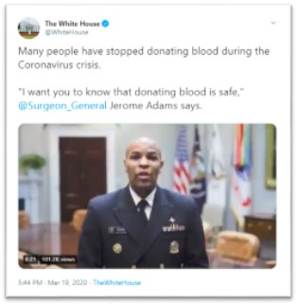While everyone is being asked to avoid mass gatherings, it’s very important to note that blood drives are ***not*** considered “mass gatherings.” Blood drives are controlled events with trained staff and appropriate safety measures to protect donors and recipients – as you all know better than anyone. Like a hospital, grocery store, or pharmacy, a blood drive is essential to ensuring the health of the community.

It is possible to practice social distancing and donate blood. In fact, the U.S. surgeon general has said, “(Y)ou can still go out and give blood. We’re worried about potential blood shortages in the future. Social distancing does not have to mean social disengagement.” We are so grateful to the surgeon general and [CDC](http://s2.bl-1.com/h/cPlMNYvQ?url=https://www.cdc.gov/media/releases/2020/s0319-cdc-encourages-donating-blood.html) for their support.

To this point, as we see areas of the country follow shelter-in-place or lock down guidance, it’s important to remember that Red Cross staff are essential and that our Biomedical Services operations will continue unless you hear otherwise from your regional leadership.

**Why We Are Not Using Face Masks**

Many of you have asked for face masks while working at blood drives over the past couple of weeks, so I want to take a minute to clarify the reasoning behind our current guidance.

The CDC recommends wearing a facemask if you are sick or if you are a frontline healthcare worker caring for someone with or suspected to have this coronavirus. In alignment with this and AABB recommendations, blood collection staff are not currently advised to wear additional personal protective equipment.

Right now, there is a shortage of personal protective gear in the U.S., including facemasks. As a humanitarian organization, we at the Red Cross must be mindful of the broader needs of frontline healthcare workers in the medical community. We do not want to further add to demand that may decrease availability for those fighting the spread of coronavirus in hospitals across the country.

We believe we have the right safety protocols in place, such as the temperature check, to ensure that blood drives and centers are safe environments for our donors and staff. Please know that we will continue to closely monitor the AABB, CDC and state health officials’ recommendations for any changes and adapt as needed.

**Red Cross Volunteers and Employees Rally to Help**

This is undoubtedly a stressful time, but the best thing we can do right now is to continue to:

* Follow our safety protocols at drives and help ensure donors, sponsors and teammates have a safe and comfortable experience.
* Tell our story to encourage others to roll up a sleeve and help prevent a blood shortage.

We’re keeping the [Coronavirus Topic Hub](http://s2.bl-1.com/h/cPlMPdJS?url=https://intranet.redcross.org/content/redcross/categories/our_response/disease-outbreak/coronavirus-disease.html) updated with the latest [talking points/FAQ](http://s2.bl-1.com/h/cPlMPkjV?url=https://intranet.redcross.org/content/dam/redcross/documents/our_services/biomed-services/biomed-comms/hot-topics/coronavirus-tlk-pts-faq.pdf) and resources, including [HR guidance and information](http://s2.bl-1.com/h/cPlMPo5X?url=https://americanredcross.sharepoint.com/sites/HRCOVID-19) for you to access. So many of you are making appointments to give – and bringing your family and friends along. In turn, they are using their own influence to encourage others in their social, business and community circles to give blood – and this is making a difference.

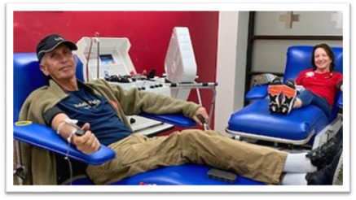Just one example is from Amanda Robinson, senior sales director, national accounts, who donated blood with her husband Fred this week in Charlotte. Amanda shared that the employees and volunteers were great, and that Fred is issuing a challenge to his tennis friends and business customers to donate blood.

Well done Amanda and Fred! It’s inspiring to take the time to notice the incredible ways that people everywhere are stepping up to help. We are One Red Cross, and we’re not in it alone.

# CDC Encourages Donating Blood If You Are Well

For Immediate Release: Thursday, March 19, 2020  
**Contact:** Media Relations  
(404) 639-3286

In healthcare settings all across the United States, donated blood is a lifesaving, essential part of caring for patients. The need for donated blood is constant, and blood centers are open and in urgent need of donations. CDC encourages people who are well to continue to donate blood if they are able, even if they are practicing social distancing because of COVID-19. CDC is supporting blood centers by providing recommendations that will keep donors and staff safe. Examples of these recommendations include spacing donor chairs 6 feet apart, thoroughly adhering to environmental cleaning practices, and encouraging donors to make donation appointments ahead of time.

###  
[U.S. DEPARTMENT OF HEALTH AND HUMAN SERVICESexternal icon](http://www.hhs.gov/)

CDC works 24/7 protecting America’s health, safety and security. Whether disease start at home or abroad, are curable or preventable, chronic or acute, or from human activity or deliberate attack, CDC responds to America’s most pressing health threats. CDC is headquartered in Atlanta and has experts located throughout the United States and the world.

**Lost units of blood due to the Coronavirus:**

**For use March 24, 2020**

**National –** More than 7,000 blood drives canceled, loss of more than 200,000 donations

**Penn Jersey Blood Region** – 399 drives canceled, loss of 12,721 donations

**NEPA Blood Region –** 63 drives canceled, loss of 1,584 donations

**Entire state of New Jersey –** 188 drives canceled, loss of 6,523 donations

**Entire state of Pennsylvania** – 420 drives canceled, loss of 12,505 donations

