Herbicides and Insecticides  Herbicides remain on the grass for some time and some make the clippings unsuitable for mulch, so it’s important to cut it and leave it when you use weed killers. Too much herbicide can burn the lawn, kill nearby plants and contaminate waterways. Instead of repeated whole lawn application of weed killers, try a one-time pre-emergent weed killer and spot application if your lawn has only a few weeds. If you see signs of insect damage, call your extension agent to determine what you need before you select an insecticide. You may find that you do not need to use any at all.  You can achieve the lawn you want and also protect the environment, when you practice careful turf management and  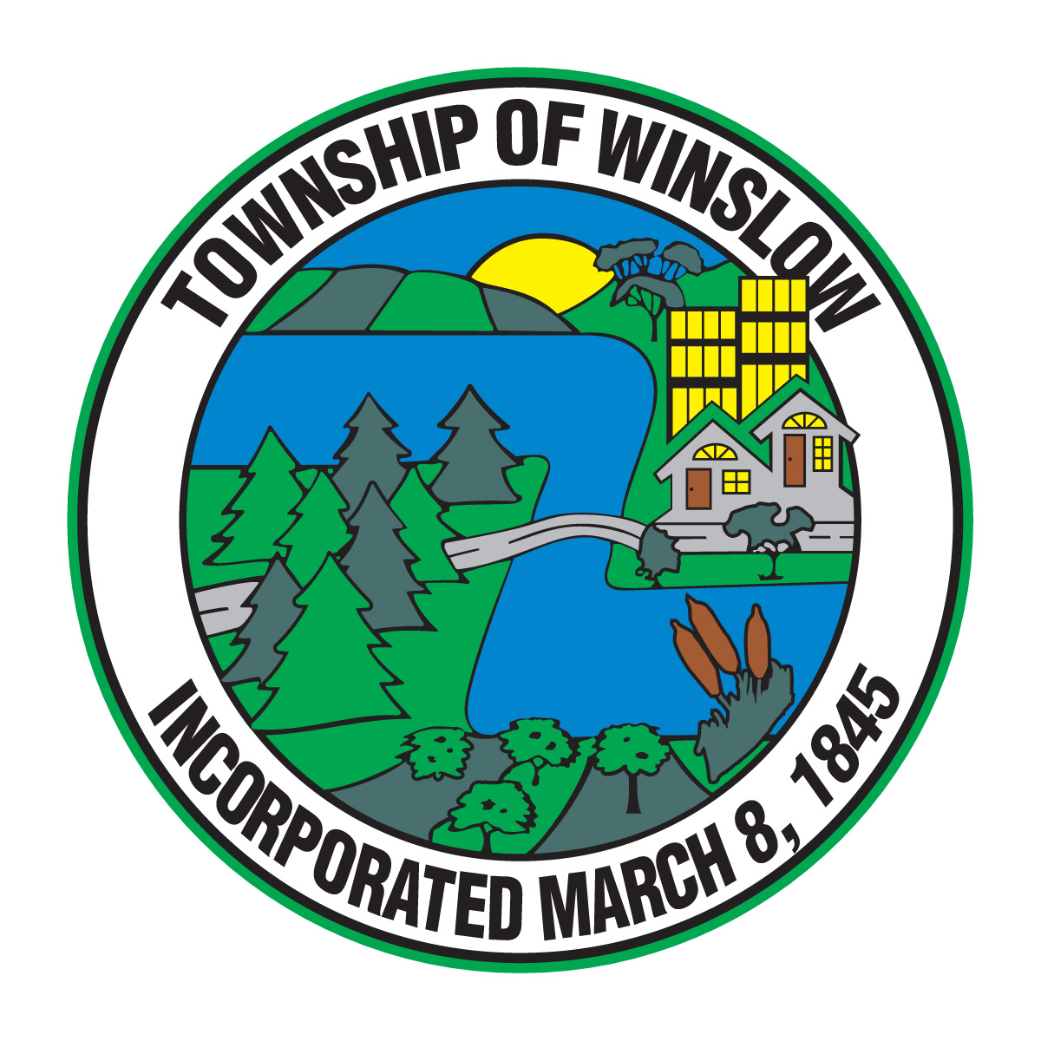  CUT IT AND LEAVE IT!  Contact Us  Township of Winslow  125 S. Route 73  Braddock, NJ 08037  Telephone: 609-567-0700  Website: www.winslowtownship.com |  |  | C  Township of Winslow  125 S. Route 73  Braddock, NJ 08037 |  | GRASS  “Cut it and Leave it…”  Enviromentally Friendly Lawn Care and How it Benefits YOUR Lawn and OUR Township

Why “Cut it and Leave it”?  Grass clippings are a major part of New Jersey’s municipal solid waste stream. As a Winslow Township resident, you are already helping to avoid air pollution and wasted resources by reducing waste at its source. By leaving the grass clippings on your lawn when you mow, you let nature do the recycling for you.  Why the Program Works  When you leave grass clippings on the lawn when you mow, it acts as a natural and healthy fertilizer for your growing lawn. By cutting your lawn short and removing the clippings, residents rob their lawns of their own natural fertilizer(s) and create waste that must be hauled away for disposal by a truck. By cutting the grass at a higher level and leaving the clippings on the lawn, residents can:  - Save Time & Money $$$  - Use Less Water & Fertilizer  - Use Less Pesticides  - Save valuable Landfill Space  - Benefit the Environment | How to “Cut it and Leave it”  Mow your lawn CORRECTLY  When you mow your lawn, the grass should be left high so that your grass clippings are short. Do not cut more than the top third of your lawn so the small clippings will filter down to the soil. It is recommended that your lawns should be mowed 2 ½ to 3 ½ inches high, especially during the hot summer months, to shade the soil, cool the roots and block weed growth. Mulching mowers help by chopping the clippings into fine pieces that slip easily down to the soil. Most new mowers are mulching mowers and if not, you can attach mulching equipment to your existing mower.  Save Time and Money $$$  Since the grass is no longer bagged, fewer stops are required and no more dragging bags out to the curb. The overall time spent on lawn care decreases by 20-25% with the elimination of bagging, even when mowing increases to once every four to seven days. You also experience savings in no longer having to purchase yard waste bags. As a result, you will need to fertilize 25-50% less, since the clippings return nutrients to the soil.  Thatching  Clippings do not cause thatch. Thatch is formed from the accumulation of dead roots and stems. The more you fertilize and water your lawn, the more it grows and the faster thatch accumulates. Deep, infrequent irrigation minimizes that accumulation. |  | Use less WATER  Controlling watering rates will help your lawn to grow at manageable levels and still stay healthy.  - Don’t water until the lawn is dry. If it turns blue-green or gray, or if footprints don’t spring back, it’s time to water. Consider only watering on odd or even days.  - Water an inch at a time for clay soil and a half an inch for sandy soil. Place cans around your lawn to see how long it takes for that much water to collect.  - Early morning watering conserves water by preventing evaporation  Fertilizer  Your soil supplies some of the nutrients that turf grass needs, but most soils are not able to provide all of them during the entire growing season. A healthy and actively growing lawn uses a great deal of energy. Fertilizer helps your lawn stay healthy by:  - Promoting new leaf and root growth aiding in recovery from foot traffic and pest damage  - Reducing and controlling weeds  - Replacing nutrients lost to leaching, volatilization and grass clipping removal  Fertilize in September and again in October or early November for a healthier lawn. This will keep your lawn greener through the winter and strengthens roots for thick growth in spring without the unwanted long growth cause by spring fertilization. This means fewer mowing’s, fewer clippings and less work.

