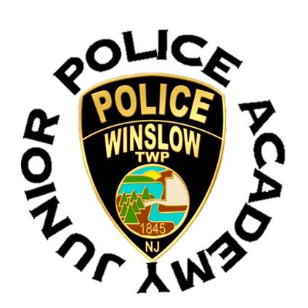
Winslow Township Police Department
125 S. Route 73 Braddock, NJ 08037
609-567-0700

JUNIOR POLICE ACADEMYAPPLICATION

PERSONAL

Name: | Date of Birth:
Home Address:

Home Phone: | Cell Phone:
Mother’s Name: | Father’s Name:
Mother’s Cell Phone: | Father’s Cell Phone:

EDUCATION

Attach a copy of the most recent report card.
Name of School Enrolled: | Highest Grade Completed:
Name of Principal: | School Phone:

BACKGROUND

Please explain briefly why you wish to be enrolled in the Winslow Township Police Department Junior Police Academy. (Space Available on last page if necessary)

Please list any associations, clubs, organizations you may belong to or be affiliated with.

Have you ever been arrested for, convicted of, and or cited for any offense? Yes___ No___ If yes, explain in detail listing appropriate dates, charges, and location actions were taken.

SPONSOR

Attach a letter provided by the selected sponsor. (Principal / Guidance Department, Law Enforcement Agency, a community representative, coach, or religious leader.)

Sponsor’s Name: | Sponsor’s Position:
Address of Sponsor:

Phone Number:

REFERENCES

Reference #1 Name:

Relationship:

Address: | Phone Number:
Reference #2 Name:

Relationship:

Address: | Phone Number:

EMERGENCY CONTACT

Please list two immediate family members or close relatives that can be contacted in the event of an emergency.

Name: | Relationship:
Address: | Phone:
Name: | Relationship:
Address: | Phone:

MEDICAL INFORMATION

This information is given voluntarily and is part of my health record maintained by the Winslow Township Police Department. This information will be kept confidential and referred only in the event of an emergency.

Please list any medications either prescribed or over the counter that you are currently taking. Describe the purpose the medications are prescribed.
__________________________________________________________________________________________________________________________________________________________________________________________________________________________________________

Describe any Allergies You May Have:

Review this application and answer carefully. Read the statement below prior to signing.

“I hereby certify that there are no willful misrepresentations, omissions, or falsifications in the foregoing statements and answers to the questions. I understand that any omissions or false statements on this application shall be sufficient cause for rejections of enrollment or dismissal from the Winslow Township Department Junior Police Academy.”

“I further understand that the Winslow Township Police Department will be conducting a thorough background investigation which may include, but not limiting to, any criminal history and personal references checks.”

_________________________________________ | ____________________
Signature | Date

Please utilize this page for any additional information.

_______________________________________________________________________________________________________________________________________________________________________________________________________________________________________________________________________________________________________________________________________________________________________________________________________________________________________________________________________________________________________________________________________________________________________________________________________________________________________________________________________________________________________________________________________________________________________________________________________________________________________________________________________________________________________________________________________________________________________

T-Shirt Size(adult sizes) -- S M L XL XXL

JPA STAFF ONLY
Received by: | Received Date:
Accepted into Class: Yes No | Date of Class:

