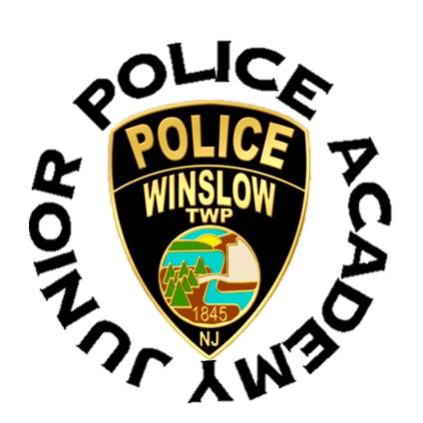
Winslow Township Police Department
125 S. Route 73 Braddock, NJ 08037
609-567-0700

DISCLAIMER AND WAIVER OF LIABILITY

The Winslow Township Junior Police Academy is provided as a public service by the Winslow Township Police Department. By execution of this form, the undersigned grants permission for their child/minor to participate in the program. The execution of this form also represents acknowledgment by the undersigned that participants in the program will be exposed to crime scene photographs, police videos, use of force scenarios, scenes with firearms simulators, and potentially violent canine demonstrations. Some of these situations may be offensive and disturbing to some participants and the signature below acknowledges that the parent/guardian understands this and grants permission for their child / minor to participate.

RESTRICTIONS OF LIABILITY

The Winslow Township Police Department makes no claims, promises or guarantees about the Academy and expressly disclaims liability for errors and omissions in the contents of the Academy. No warranty of any kind, implied, expressed or statutory, is given with respect to the contents of this Academy. Reference in the Academy to any specific commercial products, processes, or services, or the use of any trade, firm or corporation name is for the information and convenience of the public, and does not constitute endorsement, recommendations, or favoring by the Winslow Township Police Department.

_____________________________________ __________________________________
Participants Name / Age Parent / Guardian Name Print

_____________________ __________________________________
Date Parent / Guardian Signature

