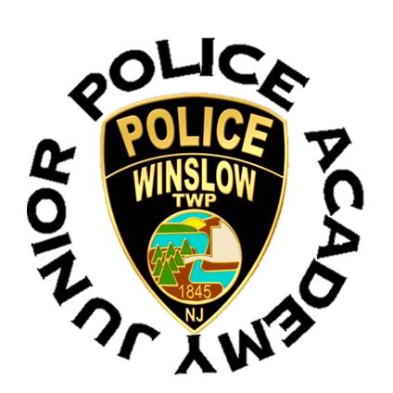
Winslow Township Police Department
125 S. Route 73 Braddock, NJ 08037
609-567-0700

LIABILITY RELEASE FORM

(Please Print)

I, the undersigned, (Parent’s Name) _________________________________________ residing

at (Address)_______________________________________, State of NJ,

being the parent or legal guardian of (Participant’s Name)_______________________________,

do hereby give my permission for him/her to attend the Winslow Township Junior Police

Academy (WTJPA) and in consideration of allowing him/her to participate in the above mentioned

program.

Voluntarily and knowingly I assume all risks and hazards incidental to such participation and shall indemnify, save harmless and defend the Winslow Township Junior Police Academy and the Township of Winslow, its employees, agents, volunteers and others working on behalf of the Township, from and against any and all claims, losses, costs, attorney’s fees, damages, or injury including death and/or property loss, expense claims or demands arising out of the APPLICANT’S participation in the WTJPA release and discharge the Junior Police Academy, Township of Winslow, Camden County, the Winslow Township Police Department’s employees, agents, successors, assigns and all others who may be liable from all claims, present and future, known or unknown, in any manner arising out of his/her participation in the Junior Police Academy.

I also acknowledge that (Participant’s Name)______________________________has no

limiting medical conditions and is fully capable of participating in the program. I appoint the Winslow

Township Police Department to act in my place, in the event that (Participant’s Name)

______________________________ should require medical attention while involved in

the Junior Police Academy program. This appointment is for the purpose of securing benefits

for the health and welfare of (Participant’s Name)______________________________ and

expressly includes the authority to sign releases to physicians who may render emergency

medical care and services. I promise to assume liability for payment of all such professional

services, and to reimburse the Township of Winslow for any expense that may be incurred for

treatment, care, drugs, and other services for (Participant’s Name)_______________________________.

In consideration of all above as well as the supervision provided on my behalf and on behalf of

(Participant’s Name)______________________________. I hereby agree to hold the Winslow

Township Police Department, Township of Winslow employees, agents, successors, assigns,

its agents and all others who may be liable, harmless for results of any decision it may make in

connection with the care and treatment of (Participant’s Name) ___________________________.

I agree that if the above mentioned participant’s behavior is such that it endangers the welfare of

the entire group, the Township of Winslow and Winslow Township Police Department has my

permission to send him/her home.

I agree to allow the Winslow Township Police or Township of Winslow to display pictures/video of my child to be used for future lawful purposes.

____________________________________________ ___________________
Signature of Parent or Guardian Date

_____________________________________________

_____________________________________________
Address

_____________________________________________
Home Phone

_____________________________________________
Work or Cell Phone

Subscribed and sworn to before me this __________ day of 20______.

