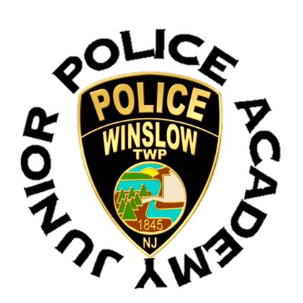
Winslow Township Police Department
125 S. Route 73 Braddock, NJ 08037
609-567-0700

Medical Waiver and Information

Parent/Guardian does your child have any medical condition or pre-existing injuries that might be helpful for the instructors to know before or during the time they are attending the Winslow Township Junior Police Academy? (Examples include but are not limited to the following: allergies, asthma, diabetes, sprains, muscular issues, and/or any other physical or mental issues that may need to be considered during the training)
YES_____ NO_____
If YES, please explain: ___________________________________________________________________ _____________________________________________________________________________________

List any medications your child may be taking or need during the summer time Junior Police Academy. NOTE: The police will NOT assist the cadet with taking their medication. __________________________ _____________________________________________________________________________________

Parent/Guardian by signing this form you give permission of any and all medical attention necessary to be administered on behalf of your child in the event of an accident, injury, sickness, etc., until such time as a parent/guardian can be contacted and respond to take custody of the child. I also assume responsibility for the payment of any such treatment to include but not limited to ambulance and hospital services.

Parent/Guradian signature: ______________________________

Witness Signature: _____________________________________

