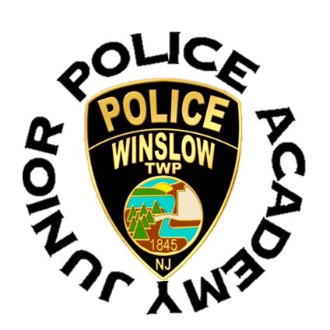
Winslow Township Police Department
125 S. Route 73 Braddock, NJ 08037
609-567-0700

PHOTOGRAPH RELEASE FORM

Today’s Date: ______________

I hereby grant the Winslow Township Police Department and its representatives, permission to use my likeness in a photograph in any and all of its publications, including websites, without payment or any other consideration.

I understand and agree that these items will become the property of the Winslow Township Police Department and will not be returned.

I hereby irrevocably authorize Winslow Township Police Department to edit, alter, copy, exhibit, publish or distribute this photo for purposes of publicizing events and activities administered by the Winslow Township Police Department or for any other lawful purpose. In addition, I waive the right to inspect or approve the finished product, including written or electronic copy, wherein my likeness appears.

I hereby hold harmless and release and forever discharge the Winslow Township Police Department and its representatives from all claims, demands and cause of action which I, my heirs, representatives, executors, administrators, or any other persons acting on my behalf or on behalf of my estate have or may have by reason of this authorization.

I am 18 years of age and am competent to contract in my own name; or I am the parent/guardian of a minor within the photograph, and I have read this release before signing below and I fully understand the contents, meaning and impact of this release.

_____________________________ ______________________________Date: _________
Signature Printed Name

_____________________________ Date: ________________
Parent/Guardian Signature

