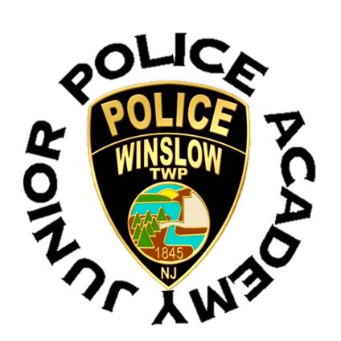
Winslow Township Police Department
125 S. Route 73 Braddock, NJ 08037
609-567-0700

Authorization and Permission form to attend the Junior Police Academy
The undersigned parent/guardian gives authorization and permission for their child to attend the Winslow Township Junior Police Academy. The parent/guardian understands that the program includes, but is not limited to, physical fitness activities, marching, classroom training, hands on training, and a possible field trip to a location that will be determined in the future.
The parent/guardian further acknowledges that their child is in good physical condition to participate in every part of the Winslow Township Junior Police Academy. The parent/guardian and cadet agree to obey reasonable direction given by the instructors and staff running the Winslow Township Junior Police Academy.
Cadets can withdraw from the Winslow Township Junior Police Academy upon request and their parent/guardian will be called immediately. A cadet’s ability to participate in the Winslow Township Junior Police Academy can be rescinded at any time during the course of the academy at the discretion of the academy instructors. An example of a cause for dismissal would be creating a dangerous situation, not listening to staff of the Winslow Township Junior Police Academy, rude behavior, bullying or mistreatment of other cadet’s.
The undersigned parent/guardian hold the township of Winslow, the Winslow Township Police Department, and the instructors of the Winslow Township Junior Police Academy free from any and all liability, claims and cause of action that a cadet may have during any participation in the Winslow Township Junior Police Academy. The parent/guardian agrees to allow the Winslow Township Police or Township of Winslow to display pictures/video of their children to be used for future lawful purposes. The Winslow Township Police Department agrees to provide a safe environment and quality instruction at all times while trying to introduce cadet’s to the initial phases of a career in policing.
The parent/guardian is hereby requesting that their child be accepted into the Winslow Township Junior Police Academy.
I hereby agree to having read and understanding the content of this document.
Parent/Guardian signature _______________________________________________________________
Parent/Guardian printed name ___________________________________________________________
Witness signature/badge # _______________________________________________________________

