DOMINIC MAIESE MUNICIPAL COMPLEX  125 South Route 73  Braddock, NJ 08037-9422  Tel:(609) 567-0700 x5100  mayorlawrence@winslowtownship.com | Office Of Mayor  Marie D. Lawrence

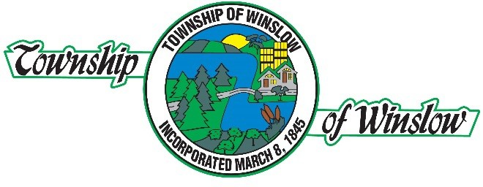
February 6, 2026

Dear Winslow Township Youth (High School Juniors and Seniors):
The New Jersey State League of Municipalities and I have an excellent scholarship opportunity for the high school juniors and seniors from Winslow Township.

We have teamed up to offer three $1,000.00 scholarships through the Louis Bay 2nd Future Municipal Leaders Scholarship State Competition. This statewide scholarship competition centers on the theme "What I Like About My Hometown" and seeks to advance the virtues of elected and volunteer members of the municipal government.

Elected officials and appointed volunteer board members serve Winslow Township, along with a cadre of dedicated professionals, who are guardians of our hometown's comforts and security.
They give of their time and talents to help plan our community and preserve our way of life. Winslow Township has worked very hard to ensure residents of all ages have a wonderful place to call home.

Full details on the application process and contest are enclosed. I hope to see many of our young adults representing Winslow Township in the Louis Bay 2nd Future Municipal Leaders Scholarship Competition.

Please return your application and essay to my office no later than end of business day on March 9th, 2026. Directions are enclosed on the application.

Regards,

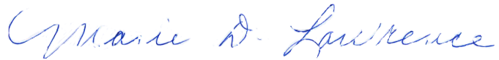

Marie D. Lawrence
Mayor of the Township of Winslow

The Louis Bay 2nd Future Municipal Leaders Scholarship Competition Application and Selection Process
(Please keep these instructions with the application)

Open to all high school juniors and seniors who are residents of New Jersey and plan to continue their education after high school.

- Complete the application and essay.

- Return them to your Hometown Mayor’s Office (or the location designated by your Mayor).

Regional Or Private High School Students: PLEASE NOTE THAT THE APPLICATION AND ESSAY MUST BE RETURNED TO YOUR HOMETOWN MAYOR, NOT THE MAYOR Of THE MUNICIPALITY WHERE YOUR HIGH SCHOOL IS LOCATED (UNLESS THAT IS YOUR HOMETOWN).

- The mayor or a designated committee will select one semi-finalist from your municipality.

- All entrants will receive a certificate of participation from the Mayor’s office.
- The winner from each municipality will be designated as a state semi-finalist. They will have their essay and application reviewed by the Scholarship Committee of the New Jersey State League of Municipalities.

- All state semi-finalists will receive a certificate attesting to their status as state semi-finalists.
- The Scholarship Committee will select 15 finalists and 3 winners.

- The 15 finalists will each be awarded finalist certificates. The three winners will each be awarded $1,000.00 by their mayor at a hometown ceremony.

- Winners’ essays will be featured in the New Jersey Municipalities magazine.

The 2026 Louis Bay 2nd Future Municipal Leaders Scholarship Application

Name

Address

City State Zip

Phone Number Email
Municipality In Which You Reside

Current School Grade Attending

Colleges or Schools To Which You May Apply

Area of Municipal Govt/Administration That Interests You

Write an essay on the theme "What I Like About My Hometown". Your essay should be based on your perceptions and experiences with your municipality’s local government. The essay should consider the public contributions of your municipal government.
Length: Approximately 500 words. Recommended Times New Roman, Double space, 12- font. Please use paper clips, not staples.
Deadline: Essays must be submitted to your hometown mayor by March 9, 2026 Judging Criteria: -- Judging is based solely on the essay. Please do not include any other
information such as transcripts and references.
-- Appropriateness of theme
-- Effective articulation of theme
-- Originality
-- Technical composition, spelling, and syntax.

Return completed application and essay to your hometown mayor's office.

For Winslow Township Residents, Applications and Essays Are to Be Returned to:

Attn: Mayor Marie D. Lawrence Winslow Township Administration Office 125 S. Route 73
Braddock, NJ 08037

Or via email: administration@winslowtownship.com

WHAT IS THE LEAGUE?

The New Jersey State League of Municipalities is a voluntary association created to help communities do a better job of self-government through pooling information resources and brainpower. The League is authorized by state statute and since 1915, has been serving local officials throughout the Garden State. All of New Jersey’s 564 municipalities are members of the League. The 564 mayors and 13,000 elected and appointed officials of member municipalities are entitled to all of the services and privileges of the League.

The League publishes a magazine titled New Jersey Municipalities which reports up-to-the-minute information on municipal administration and procedures with practical examples, news notes, and new laws. It is one of the reading “musts” for municipal officials and is sent to more than 8,500 readers each month.

In addition to the magazine, other League services include: Bureau of Municipal Information; Ordinances and Codes; Research; Legislative Analysis; Legislative Bulletins; New Laws; Contracts, In-Service Training; Personal Consultation; Instructional Seminars and Research Publications. Nearly all League services are available through the League
website www.njlm.org.

The highlight of the year’s activities is the Annual League Conference, held each November in Atlantic City at the Atlantic City Convention Center. The Conference is an invaluable learning experience which yields benefits throughout the year. Delegates have the opportunity to learn and ask questions at more than 100 panels, clinics, workshops, and other sessions conducted by the League and the 21 associations of technical and professional employees allied with it. Commercial, government and association exhibits display the latest products and services for municipal government. At the 2025 Annual League Conference, approximately 17,000 delegates, participants and guests attended, representing the largest municipal gathering in the country.

These Organizations Form an Integral Part of the League

Association of Municipal Assessors of New Jersey New Jersey Institute of Local Government Attorneys
New Jersey Building Officials Association Municipal Clerks’ Association of New Jersey, Inc.
Municipal Court Administrators Association of New Jersey Municipal Electrical Inspectors Association of New Jersey, Inc.
New Jersey Society of Municipal Engineers, Inc. New Jersey Government Management Information Sciences
Government Finance Officers Association of New Jersey New Jersey State Fire Prevention and Protection Association
NJACCHO – Health Officers Jersey Access Group
New Jersey Municipal Management Association New Jersey Planning Officials, Inc.
New Jersey State Plumbing Inspectors Association, Inc.
New Jersey State Municipal Prosecutors Association American Public Works Association – New Jersey Chapter
Governmental Purchasing Association of New Jersey Community Recreation Society of New Jersey Registrars Association of New Jersey
Tax Collectors and Treasurers Association of New Jersey Municipal Welfare Association of New Jersey
New Jersey Association of Zoning & Planning Administrators

